|  |  |
| --- | --- |
| Name (Sap Id): | Kalpita Shankhdhar (60004210164)  Akshata Sunil Dharmadhikari (60004220125)  Prerna Sunil Jadhav (60004220127) |
| Class: | T. Y. B. Tech (Computer Engineering) |
| Course: | Software Engineering Laboratory |
| Course Code: | DJ19CEL601 |
| Experiment No.: | 05 |

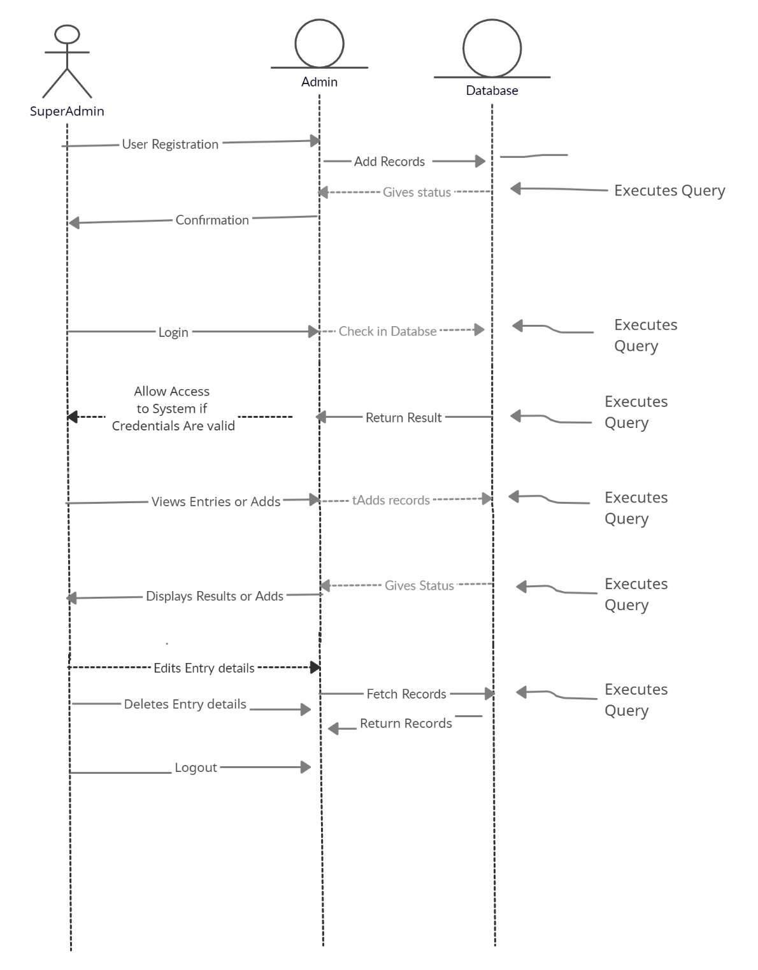**SEQUENCE DIAGRAM:**

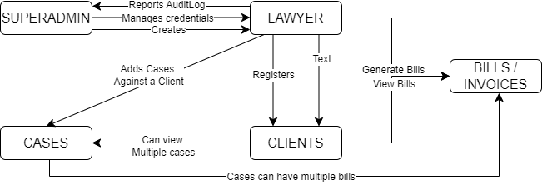**COLLABORATION DIAGRAM:**

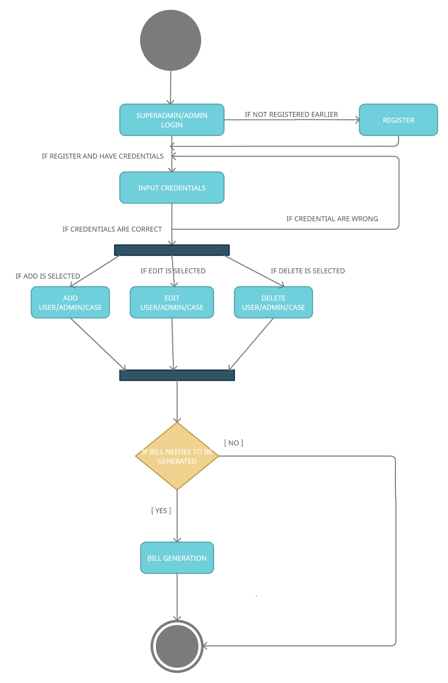**STATE DIAGRAM:**